S. No. | Name of Student | Class | Mobile No.
1 | Paras Chhabra | Cam 3 | 8376006929
2 | Kamakshi | Cam 3 | 9911766319
3 | Shivam | Cam 3 | 9716748300
4 | Radhika | Cam 3 | 9582040101
5 | Rashi | Cam 3 | 8586817469
6 | Saurabh | Cam 3 | 8745072347
7 | Zuwaria | Cam 3 | 8586095768
8 | Tanya Mittal | Cam 3 | 7838426026
9 | Apurva | Cam 3 | 8285636595
10 | Anjali | Cam 3 | 8506924046
11 | Sahil | Cam 3 | 9654868369
12 | Lakshay | Cam 3 | 8800604544
13 | Karan | Cam 3 | 8527472833
14 | Shivani | Cam 3 | 7838172310
15 | Ishika | Cam 3 | 9560746386
16 | Hardik Bansal | Gen 5 | 9868009677
17 | Shilpi | Gen 5 | 9582802851
18 | Himanshi | Gen 5 | 9958082380
19 | Viashli Rana | Gen 5 | 9540442080
20 | Sharon | Gen 5 | 9953074129
21 | Abhishek Verma | Gen 5 | 9711458544
22 | Bhavya | Gen 5 | 9999081600
23 | Aman | Gen 5 | 9650826226
24 | Kunal | Gen 5 | 9953215923
25 | Shubham | Gen 5 | 8505885744
26 | Harshjyot | Gen 5 | 9711047610
27 | Shivay | Gen 5 | 9871802535
28 | Nitin Narang | Gen 5 | 7428189336
29 | Abhishek Samant | Gen 5 | 8750302880
30 | Deepakshi | Gen 5 | 8800413440
31 | Yash | Gen 5 | 8800704506
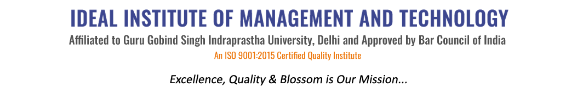
16 X, Karkardooma Institutional Area, (Near Telephone Exchange)
Delhi-110092
+91 (11) 22372639, 22375961,
http://idealinstitute.edu.in
Industrial Visit To Maruti 23-9-16

